

Guide for taking your

Episcopal Asset Map

Survey

[*www.episcopalassetmap.org*](http://www.episcopalassetmap.org)

Institution Name:

|  |
| --- |
|  |

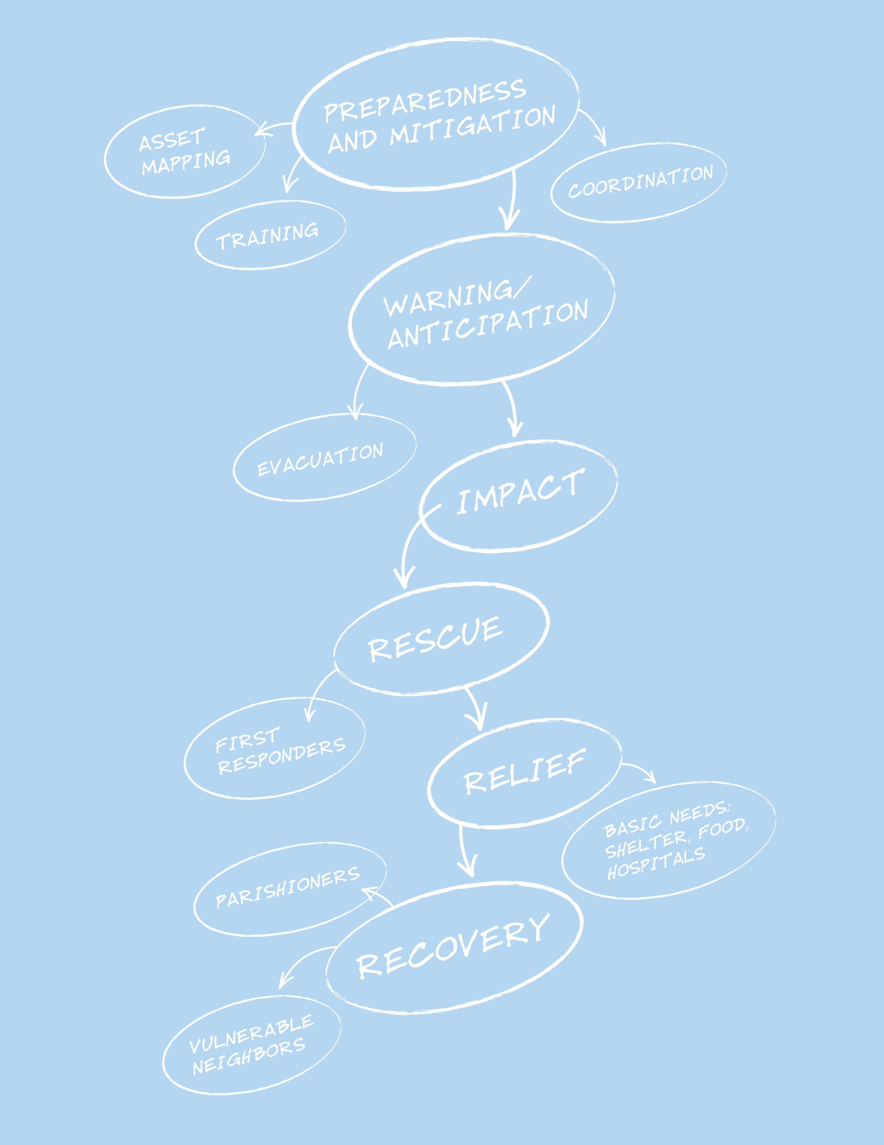

Episcopal Asset Map

The Domestic and Foreign Missionary Society and Episcopal Relief & Development have launched a new Asset Mapping platform for the Church. This free web-based platform allows Episcopal institutions to input, share and search information about their own ministry programs and those of other congregations.

The goal is to facilitate and encourage collaborative ministry and network development in The Episcopal Church by providing a platform to share information about our individual mission programs in one searchable, visual database.

The web-based platform looks like other online map applications (i.e., Google Maps) with every plotted pin representing an Episcopal institution: church, school, seminary, diocesan office, etc. Users can click the pins to read more about the institutions’ various ministries, search the diocesan map to see where similar outreach is being done or scan the list-view and see contact information to reach out to potential ministry partners.

Please use this document to help guide your congregation or other institution through the survey-taking process. Then anyone from the congregation can input the information into the site directly with assistance from your diocesan map administrator as needed. You can contact the diocesan map administrator for your diocese using the Contact form on the website.

[www.EpiscopalAssetMap.org](http://www.EpiscopalAssetMap.org)

## General Information

## Congregation or Facility: Be sure to use office phone numbers and email addresses here, not anyone’s personal accounts!

|  |  |
| --- | --- |
| **Contact Person:** |  |
| * **Email:** |  |
| * **Phone:** |  |

## Website URL:

|  |
| --- |
|  |

## Description:

Please provide a short description of your congregation, school or institution and the community that it serves. You may choose to include other information such as style of worship, history, values, etc. Note: you will have space to describe your specific ministries in another section.

|  |
| --- |
|  |

## Service Times:

You can use this area to list the regular times of worship or list hours of operation where appropriate.

|  |
| --- |
|  |

## Regular Languages of Worship:

|  |  |
| --- | --- |
|  |  |
|  |  |

## Other Local Episcopal Partners – Churches, Schools, Food Pantries, etc.:

If this facility is partnering with other churches, schools or organizations on this map, please write them here. An example of this would be a school that is directly affiliated with a specific church or an off-site food pantry with its own address/pin associated with several congregations.

|  |  |
| --- | --- |
| **Partner:** |  |
| **Partner:** |  |
| **Partner:** |  |

## Network Affiliations:

Please list any national or regional Episcopal organizations (e.g., Jubilee Ministries, National Association of Episcopal Schools, Episcopal Service Corps, etc.) this facility belongs to or is affiliated with.

|  |  |
| --- | --- |
| ☐ Adult Faith Formation | ☐ Indigenous Ministries |
| ☐ Campus Ministries | ☐ Integrity USA |
| ☐ Conference of Deaf Episcopalians | ☐ Jubilee Ministries |
| ☐ Consortium for Endowed Episcopal Parishes | ☐ Latino/Hispanic Ministries |
| ☐ Episcopal Asiamerica Ministries | ☐ Mission Enterprise Zone and Theological Education |
| ☐ Episcopal Camps and Conference Centers | ☐ Other: |
| ☐ Episcopal Migration Ministries | ☐ Other: |
| ☐ Episcopal Service Corps | ☐ Other: |

## Global Episcopal/Anglican Mission Partners, if applicable:

You can use the box below to tell us about your global mission partners, if applicable, and what types of ministry you engage in together. Feel free to include a brief overview of your relationship and how your global ministry has enriched your ministry on a local level. If there are links to more information on your parish or diocesan website, you can share those as well.

|  |  |
| --- | --- |
|  |  |
|  |  |

## Organized Groups:

|  |  |
| --- | --- |
| ☐ Adult Faith Formation | ☐ Lay Eucharistic Ministers (LEM) |
| ☐ Alcoholics Anonymous/NA/Twelve Step | ☐ Lay Pastoral Care (e.g., Stephen Ministry, Community of Hope) |
| ☐ Bible Study | ☐ LGBT Community |
| ☐ Boy Scouts | ☐ Men’s Group |
| ☐ Brotherhood of St. Andrew | ☐ Neighborhood Associations |
| ☐ Choir | ☐ Nursery |
| ☐ College Student Group | ☐ Preschool |
| ☐ Daughters of the King | ☐ Young Adult Group |
| ☐ Education for Ministry (EFM) | ☐ Youth Faith Formation/Sunday School |
| ☐ Episcopal Church Women (ECW) | ☐ Youth Group/EYC |
| ☐ Girl Scouts | ☐ Other: |
| ☐ Godly Play | ☐ Other: |
| ☐ Habitat for Humanity | ☐ Other: |
| ☐ Journey to Adulthood (J2A) | ☐ Other: |

|  |  |
| --- | --- |
|  |  |
|  |  |

Other Community Groups: List any other community groups hosted at this location.

## Property Assets

Instructions: Please check the box next to the specific assets at the property or facility. The primary purpose for this field is disaster preparedness. Note: This information will not appear on the published page for the facility.

Do you have:

|  |  |
| --- | --- |
| **Yes/No** | **Facility** |
|  | * Kitchen |
|  | * Commercial Kitchen |
|  | * Classrooms |
|  | * Meeting Spaces |
|  | * Large Meeting Space |
|  | * Gymnasium |
|  | * Back-up Power |
|  | * Garden Space |
|  | * Shower Facilities |
|  | * Ability to House Volunteers Overnight |
|  | * Large Parking Lot |
|  | * Other: |
|  | * Other: |
|  | * Other: |

Do you have a disaster plan?

☐ Yes

☐ No

### Volunteer Opportunities:

☐ Opportunities for mission groups available

☐ Opportunities for one-time volunteers

☐ Opportunities for recurring volunteer positions

Volunteer Opportunities:

You can describe the type(s) of opportunities, requirements for volunteers, contact information for interested volunteers or other relevant information here. A searchable volunteer page is coming soon. Information in this section will help connect you with people interested in volunteering.

|  |  |
| --- | --- |
|  |  |
|  |  |
|  |  |
|  |  |

### Types of Ministries:

|  |  |
| --- | --- |
| ☐ Advocacy | ☐ Food Pantries |
| ☐ Aging, Health and Wellbeing | ☐ Immigration Services |
| ☐ Career Services and Education | ☐ Meal Programs |
| ☐ Children and Youth Ministries | ☐ Mission Trips and Partnerships |
| ☐ Community Gardens | ☐ Prison Services |
| ☐ Donation Coordination/Distribution | ☐ Shelter and Housing |
| ☐ Economic Development |  |

## Ministries:

Add a description of your congregation’s ministries here. On the Asset Map website, you will be able to display these descriptions as well as any photos or videos you provide.

|  |  |
| --- | --- |
|  |  |
|  |  |
|  |  |