

Guide for taking your

Episcopal Asset Map

Survey

[*www.episcopalassetmap.org*](http://www.episcopalassetmap.org)

Institution Name:

|  |
| --- |
|  |

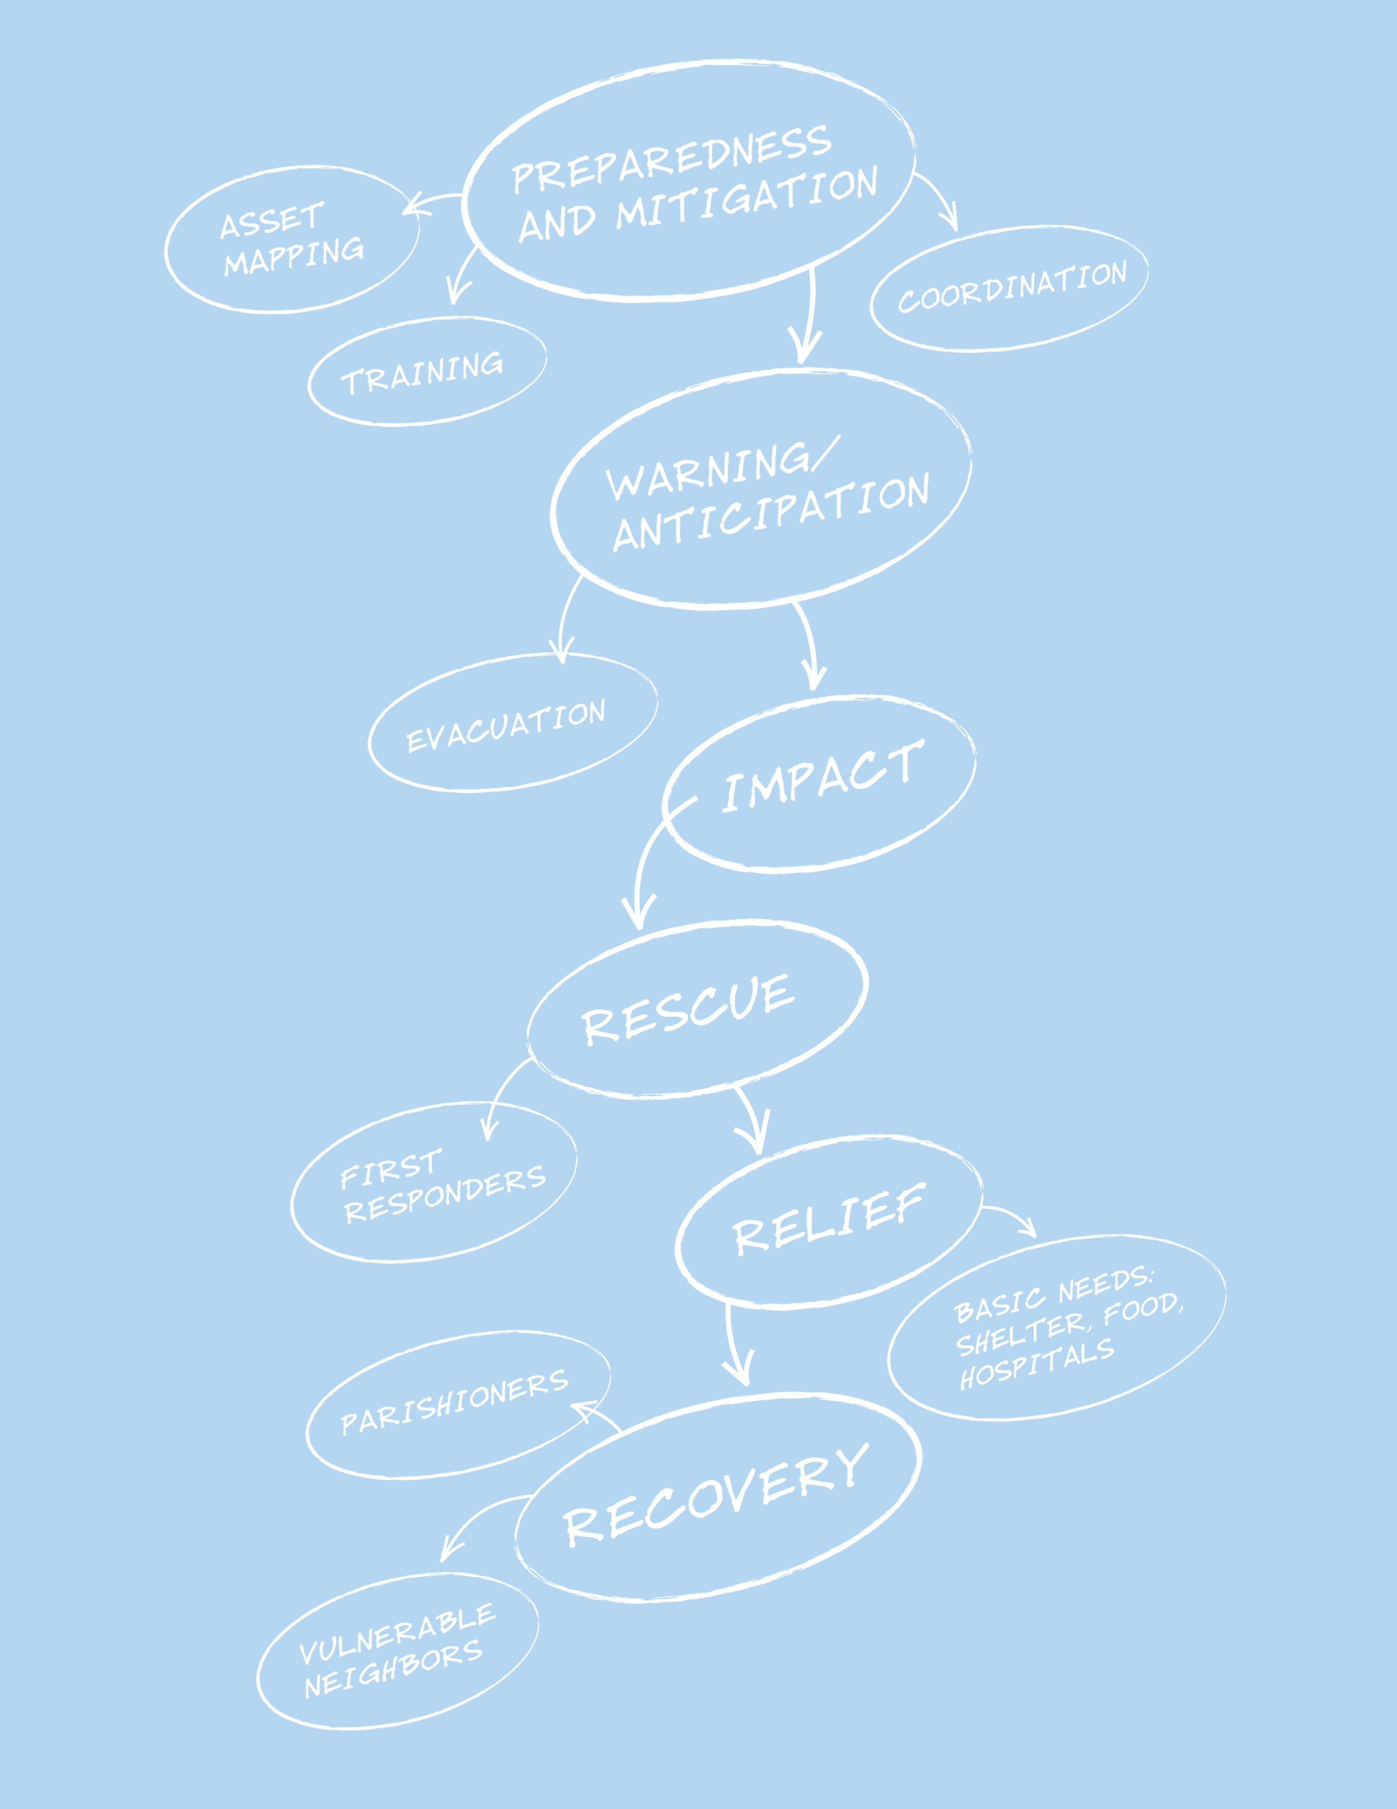

Episcopal Asset Map

The Domestic and Foreign Missionary Society and Episcopal Relief & Development have launched an Asset Mapping platform for the Church. This free web-based platform allows Episcopal institutions to input, share and search information about their own ministry programs and those of other congregations.

The goal is to facilitate and encourage collaborative ministry and network development in The Episcopal Church by providing a place to share information about our individual mission programs in one searchable, visual database.

The web-based platform looks like other online map applications (i.e., Google Maps) with every pin representing an Episcopal institution: church, school, seminary, diocesan office, etc. Users can click the pins to read more about the institutions’ various ministries, search the diocesan map to see where similar outreach is being done or scan the list-view and see contact information to reach out to potential ministry partners.

Please use this document to help guide your congregation or other institution through the survey-taking process. Then anyone from the congregation can input the information into the site directly with assistance from your diocesan map administrator as needed. You can contact the diocesan map administrator for your diocese using the Contact form on the website.

[www.EpiscopalAssetMap.org](http://www.EpiscopalAssetMap.org)

## Part 1

*1 Corinthians: 10*

*According to the grace of God given to me, like a skilled master builder I laid a foundation, and someone else is building on it. Each builder must choose with care how to build on it.*

The Episcopal Asset Map was created to support the church in understanding the vast assets we have to be able to be present to human needs. Highlighting basic information about your community allows the world to know about who you are, where you are and how you connect to the world around you: This is the foundation.

## General Information

## Congregation or Facility: It is best to use an office phone number and e-mail address as this information is public. (i.e. administrator@mychurch.org)

|  |  |
| --- | --- |
| **Contact Person:** |  |
| * **Email:** |  |
| * **Phone:** |  |

## Website URL: _____________________________

## Description:

Please provide a short description of your congregation, school or institution and the community that it serves. You may choose to include other information such as style of worship, history, values, etc. There is space later in the form to outline specific ministry and outreach projects.

|  |
| --- |
|  |

## Take a Picture of your Church:

Visuals are a great addition to any website. A small image of your church building will assist folks in knowing what your church looks like before they even drive up to visit.

## Service Times:

Use this area to list the regular times of worship and/or hours of operation as appropriate. Please remember to update your service time through seasonal changes.

|  |
| --- |
|  |

## Regular Languages of Worship:

|  |  |
| --- | --- |
|  |  |
|  |  |

## Other Local Episcopal Partners – Churches, Schools, Food Pantries, etc.:

If this facility is partnering with other churches, schools or organizations on this map, please write them here. For example, a school that is directly affiliated with a specific church.

|  |  |
| --- | --- |
| **Partner:** |  |
| **Partner:** |  |
| **Partner:** |  |

## Network Affiliations:

Please list any national or regional Episcopal organizations (e.g., Jubilee Ministries, National Association of Episcopal Schools, Episcopal Service Corps, etc.)

|  |  |
| --- | --- |
| ☐ Adult Faith Formation | ☐ Indigenous Ministries |
| ☐ Campus Ministries | ☐ Integrity USA |
| ☐ Conference of Deaf Episcopalians | ☐ Jubilee Ministries |
| ☐ Consortium for Endowed Episcopal Parishes | ☐ Latino/Hispanic Ministries |
| ☐ Episcopal Asiamerica Ministries | ☐ Mission Enterprise Zone and Theological Education |
| ☐ Episcopal Camps and Conference Centers | ☐ Other: |
| ☐ Episcopal Migration Ministries | ☐ Other: |
| ☐ Episcopal Service Corps | ☐ Other: |

## Global Episcopal/Anglican Mission Partners, if applicable:

You can use the box below to tell us about your global mission partners, if applicable, and what types of ministry you engage in together. Feel free to include a brief overview of your relationship and how your global ministry has enriched your ministry on a local level. If there are links to more information on your parish or diocesan website, you can share those as well.

|  |  |
| --- | --- |
|  |  |
|  |  |

## Organized Groups:

|  |  |
| --- | --- |
| ☐ Adult Faith Formation | ☐ Lay Eucharistic Ministers (LEM) |
| ☐ Alcoholics Anonymous/NA/Twelve Step | ☐ Lay Pastoral Care (e.g., Stephen Ministry, Community of Hope) |
| ☐ Bible Study | ☐ LGBT Community |
| ☐ Boy Scouts | ☐ Men’s Group |
| ☐ Brotherhood of St. Andrew | ☐ Neighborhood Associations |
| ☐ Choir | ☐ Nursery |
| ☐ College Student Group | ☐ Preschool |
| ☐ Daughters of the King | ☐ Young Adult Group |
| ☐ Education for Ministry (EFM) | ☐ Youth Faith Formation/Sunday School |
| ☐ Episcopal Church Women (ECW) | ☐ Youth Group/EYC |
| ☐ Girl Scouts | ☐ Other: |
| ☐ Godly Play | ☐ Other: |
| ☐ Habitat for Humanity | ☐ Other: |
| ☐ Journey to Adulthood (J2A) | ☐ Other: |

Other Community Groups: List any other community groups hosted at this location.

|  |  |
| --- | --- |
|  |  |
|  |  |

## Part II: Property Assets/Disaster Preparedness

Matthew 25: 1-5

Then the kingdom of heaven will be like this. Ten bridesmaids[[a](https://www.biblegateway.com/passage/?search=Matthew%2025&version=NRSV" \l "fen-NRSV-24007a" \o "See footnote a)] took their lamps and went to meet the bridegroom.[[b](https://www.biblegateway.com/passage/?search=Matthew%2025&version=NRSV#fen-NRSV-24007b)] **2**Five of them were foolish, and five were wise. **3**When the foolish took their lamps, they took no oil with them; **4**but the wise took flasks of oil with their lamps.

Another goal in the creation of this map is disaster response. We hope to utilize the information we have gathered to enhance our abilities to coordinate appropriate responses to disasters. Understanding the facilities and gifts around the church allow us to better connect resources to those who need them the most.

Instructions: Please check the box next to the specific assets at your property or facility. The primary purpose for this field is disaster preparedness. Note: This information will not appear on the published page for the facility.

Do you have:

|  |  |
| --- | --- |
| **Yes/No** | **Facility** |
|  | * Kitchen |
|  | * Commercial Kitchen |
|  | * Classrooms |
|  | * Meeting Spaces |
|  | * Large Meeting Space |
|  | * Gymnasium |
|  | * Back-up Power |
|  | * Garden Space |
|  | * Shower Facilities |
|  | * Ability to House Volunteers Overnight |
|  | * Large Parking Lot |
|  | * Other: |
|  | * Other: |
|  | * Other: |

Do you have a disaster plan?

☐ Yes

☐ No

## Volunteer Opportunities:

☐ Opportunities for mission groups available

☐ Opportunities for one-time volunteers

☐ Opportunities for recurring volunteer positions

Volunteer Opportunities:

You can describe the type(s) of opportunities, requirements for volunteers, contact information for interested volunteers or other relevant information here. A searchable volunteer page is coming soon. Information in this section will help connect you with people interested in volunteering.

|  |  |
| --- | --- |
|  |  |
|  |  |
|  |  |
|  |  |

### Part III: Ministry Inventory

Matthew 25: 37-40

Lord, when was it that we saw you hungry and gave you food? We saw you thirsty and gave you something to drink? We saw you a stranger and welcomed you? We saw you sick and took care of you? We saw you in prison and visited you? “Truly I tell you, just as you did it to one of the least of these who are members of my family, you did it to me.”

This is your opportunity to think through and describe the variety of ways that you are serving as the hand of God in partnership with your neighbors. Ministry projects are the breadth and depth of ways that you are engaging your community: gardens, knitting group, day care center, after school program, bible study, yearly community feasts, etc… The goal is to help people learn more about the ways that you are engaging your congregation and community in the life of Christ.

## Types of Ministries:

These are general theme buckets of ministries in which you are engaged. Not specific descriptions of actual ministries

|  |  |
| --- | --- |
| ☐ Advocacy | ☐ Food Pantries |
| ☐ Aging, Health and Wellbeing | ☐ Immigration Services |
| ☐ Career Services and Education | ☐ Meal Programs |
| ☐ Children and Youth Ministries | ☐ Mission Trips and Partnerships |
| ☐ Community Gardens | ☐ Prison Services |
| ☐ Donation Coordination/Distribution | ☐ Shelter and Housing |
| ☐ Economic Development |  |

## Ministries:

Add a description of your congregation’s ministries here. On the Asset Map website, you will be able to display these descriptions as well as any photos or videos you provide.

|  |  |
| --- | --- |
|  |  |
|  |  |
|  |  |

## Part IV: Additional Opportunities for populating your Site

Working on the asset map isn’t just about putting information on a map. This is a wonderful opportunity to engage your congregation on important conversations about your assets. Doing cross-generational interviews as well as adding media to your congregational pin is a great way to let people know about your church. Here are some suggestions for ways to enhance your site and engage the congregation:

1. Take a picture of your church and ministry outreach projects.
2. At a coffee hour, interview members of the church about their experience.
3. Have YouTube videos already created, you can easily upload this information to the website the tab “add media”
4. Create cross-generational opportunities for conversation in your church: Have young people interview heads of ministry projects and write up short descriptions for the ministry page. In turn, have adult congregants interview young people about how they participate in the life of the church.