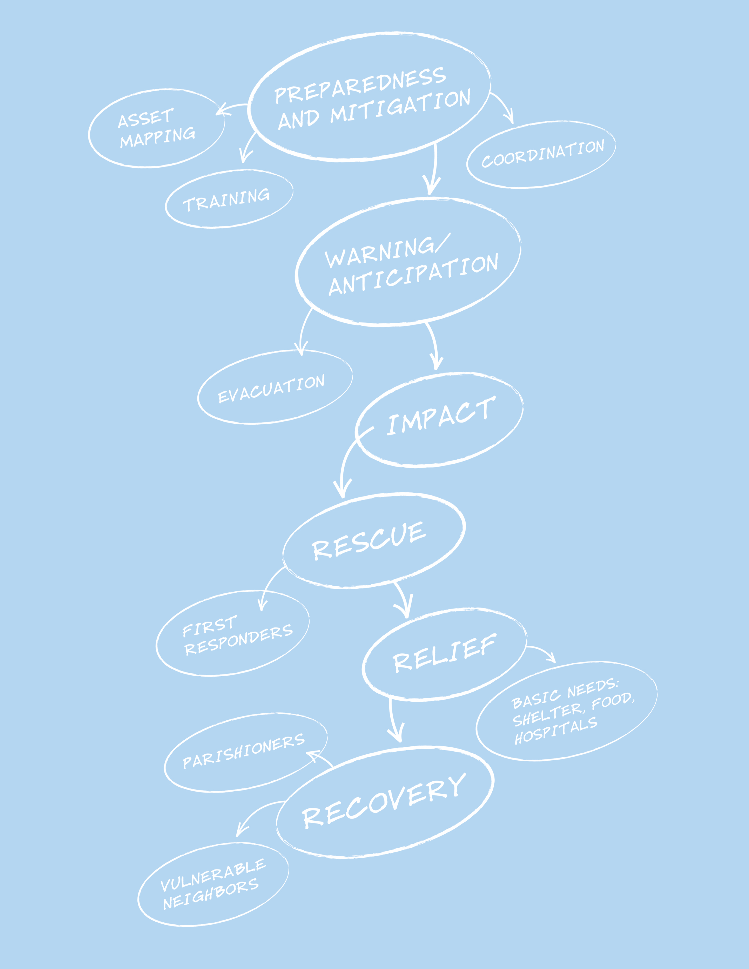

Preparedness Planning Guide

For Congregations and Parishes
(Silver Level Version)

From the Director

Dear Episcopal Church Leaders,

Though we don’t always want to think about it, one of our roles as a church in the community is to be prepared to be of assistance after a disaster. We plan for four basic reasons:

- To mitigate the damage to our church community’s buildings and belongings;
- To be able to resume the business of the church as soon as possible post-disaster;
- To support our parishioners in times of crisis;
- To assist to our vulnerable neighbors after an emergency.

The role of Episcopal Relief & Development’s US Disaster Program is to inspire, connect and equip leaders of the US Episcopal Church to prepare for hazards that might affect their communities, as well as mitigate the impact of those disasters and help the vulnerable make a full and sustained recovery.

The Preparedness Planning Guide for Congregations and Parishes is designed to help a congregation plan for a disaster, from taking inventory of physical and human assets to determining its niche in assisting vulnerable people in the larger community. The “Comprehensive Version” if the guide takes about 10 to 15 hours to complete. But we recognize some congregations might not yet be ready for the full process. So we have created this “Silver Level” version, which includes necessary basic information to protect parishioners and church property in times of disaster, and also lays the foundation for congregations interested in responding to their most vulnerable neighbors after a disaster.

A“Bronze Level” version that gathers the most basic information needed in times of disaster is also available. All three versions of the planning guide can be downloaded from the Resource Library of our website, www.episcopalrelief.org/resourcelibrary. An index that cross-references the sections of all three guides can be found at the end of this resource.

Episcopal Relief & Development’s US Disaster Program is working with dioceses around the country to help them be better prepared for emergencies. That includes training and supporting Diocesan Disaster Coordinators, who have been appointed by their bishops. A list of Diocesan Disaster Coordinators can be found on our website at www.episcopalrelief.org/usdisasterprogram. These coordinators should be your first support and resource through this planning process.

The Preparedness Planning Guide for Congregations and Parishes comes from the collected wisdom of the Church. To compile this guide, we gathered examples of parish and diocesan disaster preparedness guides from around the country as well as from other denominations. We utilized the most important elements from each, while trying to stay as simple as possible. Please let us know if there’s anything in this guide that you think should be changed, added or eliminated, and feel free to edit according to your local context.

Thanks for all you do in this important work,

Katie Mears
Director, US Disaster Program
Episcopal Relief & Development
Thank-you

This guide is not the creation of Episcopal Relief & Development’s US Disaster Program; it is a compilation of the great work of:

Province IV Disaster Preparedness and Response Commission
The Episcopal Diocese of Arkansas
The Episcopal Diocese of Central Florida
The Episcopal Diocese of Central Pennsylvania
The Episcopal Diocese of Connecticut
The Episcopal Diocese of East Tennessee
The Episcopal Diocese of Florida
The Episcopal Diocese of Kansas
The Episcopal Diocese of Louisiana
The Episcopal Diocese of Rio Grande
The Episcopal Diocese of South Carolina
The Episcopal Diocese of Southeast Florida
The Episcopal Diocese of Southwestern Virginia
The Episcopal Diocese of Texas
The Episcopal Diocese of West Tennessee
The Episcopal Diocese of West Texas
Lutheran Episcopal Services in Mississippi

This work owes special thanks to:
Karin Hamilton and her committee in the Diocese of Connecticut
and Carolyn Gibbs in the Diocese of Texas

Dave Baylor
Dianne Britton
The Rev. Daniel Harris
Sharon Jones
The Rev. Curtis Metzger
The Rev. Canon E. Mark Stevenson
Carol Stewart
Ryan Velasco
The Rev. Paul Wehner

and

Participants of the Disaster 101 Training in the Diocese of Olympia

© Copyright 2011
Table of Contents
Leadership
Who will take responsibility for preparedness activities?
• Disaster Leadership Team – Contact Information | 7
Goals
What does your congregation want to do in case of disaster?
• Preparedness Goals
• Congregational Goals | 8
Risk Assessment  What emergencies have happened before and what should you prepare for? | 8
• Brainstorm Possible Disasters and Emergencies
• Identify Groups that Include or Serve Vulnerable People
Property Assets  What do you have that you need to protect? | 9
• Inventories of Property-Related Assets | 10
• Insurance Information
• Secure Storage of Archives and Records | 11
Response & Recovery Capacity
What and who do you have that will help you respond after an emergency?
• Congregational Resources
• Congregational Property Resources for Use Post-Disaster
• Congregational Activities Resources
• Goals and Response | 12
Communication & Outreach  Who do you need to contact after an emergency, how and for what purpose? | 13
• Diocesan Contact Information
• Church Staff Contact Information | 14
• People with Financial Authorization Approval | 15
• Congregation’s Emergency Contact
• Outside Users of the Building
Developing Templates for Initial Response  The first steps you should take in the immediate aftermath of a disaster | 17
• Example: Major Disasters with Warning
• Example: Local Emergency with No Warning
• Template: Major Disaster with Warning | 18
• Template: Major Disaster with No Warning | 19
• Template: Local Emergency with Warning | 19
• Template: Local Emergency with No Warning | 20
Appendix: Table of Contents, All Versions  Compares Comprehensive, Silver and Bronze versions | 29

Our Congregation’s Disaster Plan

- Congregation/Church:
- Phone:
- Address:
- Congregational Disaster Coordinator:
- Cell-phone:
- Landline:
- Diocesan Disaster Coordinator:
- Cell-phone:
- Landline:
- Date of Completion:
- Scheduled Review:

Disaster Leadership Team:

Contact Information

Instructions: Fill out the following form with contact information for your Congregational Disaster Coordinator and the Disaster Leadership Team. Even if your team consists of two people, capture their contact information.

Congregational Disaster Coordinator: | - Landline:
Congregational Disaster Coordinator: | - Cell Phone:
Congregational Disaster Coordinator: | - Email:
- Name: | Role/Designated Tasks:
- Name: | Address:
- Name: | Landline:
- Name: | Cell Phone:
- Name: | Email:
- Name: | Role/Designated Tasks:
- Name: | Address:
- Name: | Landline/Phone:
- Name: | Cell Phone:
- Name: | Email:
- Name: | Role/Designated Tasks:
- Name: | Address:
- Name: | Landline:
- Name: | Cell Phone:
- Name: | Email:
- Name: | Role/Designated Tasks:
- Name: | Address:
- Name: | Landline:
- Name: | Cell Phone:
- Name: | Email:
- Name: | Role/Designated Tasks:
- Name: | Address:
- Name: | Landline:
- Name: | Cell Phone:
- Name: | Email:
- Name: | Role/Designated Tasks:
- Name: | Address:
- Name: | Landline:
- Name: | Cell Phone:
- Name: | Email:

Preparedness Goals

In putting together this guide and talking with church leaders around the country, we have realized that all preparedness, response, recovery and hazard mitigation work can be can be categorized into four goals:

- Resume congregational life as quickly and smoothly as possible

- Protect the church’s assets

- Support impacted parishioners to recover

- Reach out to vulnerable neighbors

If your congregation is prepared, it will be able to achieve these goals more quickly and efficiently after an emergency.

Congregational Goals

This is an exercise to think of who you are as a congregation and what you want to accomplish after a disaster. This is a definition of what you will strive to accomplish after a disaster, the specific steps to accomplish these goals will be defined later in the guide.

Examples of goals may include:
- Ensure the safety of older and disabled members of the congregation
- Provide an effective relief ministry to the local community after a disaster
- Protect valuable liturgical assets
- Reestablish Sunday services as soon as possible post-disaster

1) | (Example) Reestablish Sunday services as soon as possible.  You don’t need to identify the specifics of how that will be done (i.e.- worship will be held at St. Luke’s Lutheran Church)

2)

3)

4)

5)

Brainstorm Likely Disasters and Emergencies

Make a list of all potential disasters/emergencies. Examples of common emergencies may include: weather and fire-related events, vulnerable adults, lost and missing children, medical emergencies, intruders, etc. Also consider even the most extreme possibilities: chemical spill, fire, mass violence, etc.

After you have created the lists, go through and rank the top 5 that you think are most likely. We will return to these in the final section of this guide, “Developing Templates for Initial Response.”

Major Disasters Local Emergencies
- Flood | - Ice Storm
- Hurricane | - Apartment fire in the neighborhood

Consider whether your top five events in both columns would be the type that occur with some warning, such as a hurricane or spring river flood, or would happen suddenly, such as a chemical spill. Place them in the appropriate box below.

Major Disaster with Warning | Major Disaster with No Warning | Local Emergency With Warning | Local Emergency with No Warning

Identifying Groups that Include or Serve Vulnerable People

People with special needs will be at higher risk during a disaster. Take the time to identify those people within your congregation, and brainstorm what problems they may face and how you could help with those problems as a congregation.

Instructions: List the groups in the parish that are either comprised of or serve people who might be especially vulnerable after a disaster. These might include senior citizens’ groups, groups for new mothers, and religious education programs that include children with special needs. List the contacts for each group, so that they can be contacted after a disaster to help assess needs and facilitate the response.

Group | Contact | Types of needs members might have.
The Senior Citizens Club is comprised of parishioners aged 65 and older. | Betty Jones | Difficulty evacuating. Medical conditions.
The Lay Eucharistic Visitors have a current list of people who are home-bound or who are in the hospital. | Deacon Williams | Difficulty evacuating. Medical conditions.

Inventories of Property-Related Assets

The three first steps to protecting your property are:

1) Identify what you have
- Make a list of your major assets.

2) Record the details of this property
- Make a written inventory of any property, buildings and building contents (you can use the form on the next page). It should list what you have and provide appraisals when possible.
- Make a visual record with a camera and/or a handheld video camera: lay out your valuables – vestments, silver, artwork, historical items, etc. Take photos of each or, with a camcorder, pan slowly across each. Continue the visual record by walking through buildings/properties, stopping at specific points for more detail as needed.
- Keep one copy of the written and visual inventories in a protected place at the church, and keep a second copy of each in a remote location or provide them to the diocesan archives. You may have this already if you’ve completed one for insurance purposes; if so, make sure it’s up to date and that the diocesan archives has a copy.

3) Determine what needs to be removed or protected
- Identify what should be protected or removed. This may include protecting the organ, piano, windows, or archives; quake-proofing furniture, etc.
- Decide and record what will be protected, by whom, when, where, and how. Buy any supplies needed to protect those objects, and have them readily accessible.
- Draw a simple floor plan of your building/s, showing the location of the organ, piano, paper records, archives, etc. and file it with your local fire department.
- Make sure copies of your insurance information are kept in a safe on site and in a safe place off-site.

General Inventory Information:

Annual Inventory Date:
- List Only (m/d/y)
- Photos (m/d/y)
- Video (m/d/y)
Person(s) Responsible for Conducting Annual Inventory:
- Name:
- Name:
- Name:
Locations of Inventory Records:
- On-Site:
- Off-Site:

Insurance Information

Make a list of all your insurance information and contacts. Be sure to have a copy of this information in a secure place off-site and have another copy that someone can take with them if your community is evacuated. Note: if your church is insured through Church Insurance Company, you can call 800-223-5705 to report claims immediately.

- Policy Number:

- Policy is with:
Phone:
Address:
- Agent:

Phone:
Address:
- Original Policy is kept:

Address:
- Copy of policy is kept offsite:

Address:
- Policy Type: | (Example – Replacement value type)
Total Value:
- Policy covers: | Earthquake, hurricane, robbery, fire, breakage, etc.
- Other policies:
- Policy review:
When:
By who:

Be sure to note where off-site copies are kept and who can access them.

Off-site Copies
- Where: | (Ex: Diocese has a copy)
- Who: | Susan Wu
Phone: | xxx-xxx-xxxx
Cell:

Secure Storage of Archives and Records (print and electronic)

Appropriate protection of records is essential. If your paper files are charred or water-damaged, or your computer files are lost, you may need to hire professional recovery companies in addition to rebuilding the data. Archival items by nature are irreplaceable.

Refer to the “Records Manual for Congregations” published by the Archives of the Episcopal Church for a list of records to retain and the time to retain them. You can also find this information at: http://www.episcopalarchives.org/Records_Manual_for_Congregations.pdf

- Every congregation needs a fireproof, waterproof, quake-proof lockable box or safe (or safety deposit box). Seldom-used/historical items, valuables and the following should be kept in the safe:
- Parish registers and service books – at all times when not in use
- Confidential records: personnel files, documents displaying social security numbers, and confidential counseling records.
- Contracts, mortgage or loan papers, titles and deeds, other legal documents, etc.
- Routine back-ups for computer files on a CD, DVD or USB
- Paper records and files
- These could include your administrative, financial, and ministry files, and copies of print newsletters or bulletins. Store them in metal file cabinets, preferably not on opposite walls from windows. Photocopy irreplaceable files to store offsite.
- Archives
- These are best stored in temperatures between 65-68 degrees, with 45% humidity, in metal cabinetry or shelved in acid-free boxes, in a closed room with no windows. If the room is fireproofed, even better. After fire, water and mildew are the worst enemies.
- Inventory your archives carefully and keep a copy offsite.
- Software and electronic files
- Keep anti-virus and spyware protection up to date, establish protocols for office computer use including password protection, and use a surge protector
- Back-up your office files regularly and keep back-ups in your safe or another secure location off-site. Place a copy in the “Go Kit.”
- Keep your original software CDs in the safe.
- Make backups of your website. Make sure your web-hosting provider regularly backs up their servers and protects the data. Consider a web-hosting service with multiple servers in various locations nationally.
- Keep lists of passwords and usernames for all computers in the church safe/safety deposit box/off-site. Make sure passwords are kept in at least 2 places, and there is a copy in your “Go Kit.” This will help to ensure access to them after a disaster
- Diocesan archive storage
- Provide copies of your architectural drawings and asset inventories to the diocesan archives.

Congregational Resources

Identify what facilities or resources your congregation can offer fellow parishioners or to the broader community in the event of an emergency – do you have vehicles? Do you have a space that could be used as a shelter? Do you have a commercial kitchen?

Congregational Property Resources for Use Post-Disaster

Instructions: Make a list of property assets that can be used for response activities in case of an emergency.

List your buildings – include approximate capacity and accessibility
Building | Description

Do you have:
Yes/No | Facility | Description/Quantity
 | - Kitchen
 | - Commercial Kitchen
 | - Classrooms
 | - Meeting Spaces
 | - Large Meeting Space
 | - Gymnasium
 | - Back-up Power
 | - Garden Space
 | - Shower Facilities
 | - Ability to House Volunteers Overnight
 | - Large Parking Lot
 | - Other:
 | - Other:
 | - Other:
Are you certified:
Yes/No | Certification
 | - American Red Cross Disaster Feeding
 | - American Red Cross Mass Care
 | - American Red Cross Shelter Care
 | - Other:

What equipment/resources do you have to offer the wider community?
Yes/No | Equipment/Resources | Description/Quantity
 | - Vehicles
 | - Aircraft
 | - Boat
 | - Bus
 | - Generator
 | - Bed/Cot
 | - Tent
 | - Other:

Congregational Activities Resources

Make a list of important activities and services already provided by the congregation. What do you know how to do? What outreach programs does your congregation already run? What vulnerable communities might be associated with those programs? Because you already have the experience and infrastructure in place, these programs may be a good starting point for providing services to the greater community after a disaster.

Types of Ministries:

☐ Advocacy | ☐ Immigration Services
☐ Aging, Health, and Wellbeing | ☐ Meal Programs
☐ Career Services and Education | ☐ Mission Trips and Partnerships
☐ Children and Youth Ministries | ☐ Prison Services
☐ Community Gardens | ☐ Shelter and Housing
☐ Donations Coordination/Distribution | ☐ Other:
☐ Economic Development | ☐ Other:
☐ Food Pantries | ☐ Other:

Ministries:
- (Example) Food pantry - frequented by homeless
- (Example)Vacation Bible School for parish children and their friends
- (Example) Alcoholics Anonymous meetings
Organized Groups:

☐ Active Community Ministries Organization | ☐ Kids on a Mission
☐ AA/NA/Twelve Step | ☐ LGBT Community
☐ Bible Study Group | ☐ Men’s Group
☐ Boy Scouts/Girl Scouts | ☐ Neighborhood Associations
☐ Brotherhood of St. Andrew | ☐ Nursery
☐ Choir | ☐ Preschool
☐ College Students | ☐ Sunday School
☐ Daughters of the King | ☐ Young Adult Group
☐ Ecumenical Ministers/Lay Eucharistic Ministers | ☐ Youth Group
☐ ECW | ☐ Other:
☐ Habitat for Humanity | ☐ Other:

Congregational Human Resource Assets:

Primary Languages:
Groups that could be of service:
- (Example) Brotherhood of St. Andrew | Contact Person:
- (Example) Brotherhood of St. Andrew | Email:
- (Example) Brotherhood of St. Andrew | Phone:
- (Example) Brotherhood of St. Andrew | Resources they can provide:
- (Example) Brotherhood of St. Andrew | Skills they can provide:
- (Example) ECW | Contact Person:
- (Example) ECW | Email:
- (Example) ECW | Phone:
- (Example) ECW | Resources they can provide:
- (Example) ECW | Skills they can provide:
- (Example) Youth Group | Contact Person:
- (Example) Youth Group | Email:
- (Example) Youth Group | Phone:
- (Example) Youth Group | Resources they can provide:
- (Example) Youth Group | Skills they can provide:
 | Contact Person:
 | Email:
 | Phone:
 | Resources they can provide:
 | Skills they can provide:
 | Contact Person:
 | Email:
 | Phone:
 | Resources they can provide:
 | Skills they can provide:

Goals and Response

This is a good moment to revisit the goals defined on pg. 9 and identify the necessary steps and resources to ensure that those goals are met. This is the moment to decide what activities are needed to accomplish those goals, what preparation is needed before a disaster, who shall lead each activity and what is needed to do so.

Goal | Preparation | Person Responsible | Activities Post-Disaster
(Example) Reestablish Sunday services as soon as possible after a disaster | - Put together “Go Kit”  - Establish relationship with St. Luke’s Lutheran Church – ask if they will offer space for alternate worship site  - Inform congregation: in case church is affected by emergency, services will be held at alternate site | Paula Shriver (Senior Warden) and Rev. Smith | - Communicate with St. Luke’s  - Inform parishioners via email, phone and note at our parish that services will be held at alternate site  - Provide priest with the implements for service from the “Go Kit”

Diocesan Contact Information

Instructions: Change, remove and add titles as relevant to your diocese.

- Bishop  Name: | Address:
- Bishop  Name: | Office Phone:
- Bishop  Name: | Cell Phone:
- Bishop  Name: | Home Phone:
- Bishop  Name: | Email:
- Canon for Stewardship/Administration  Name: | Address:
- Canon for Stewardship/Administration  Name: | Office Phone:
- Canon for Stewardship/Administration  Name: | Cell Phone:
- Canon for Stewardship/Administration  Name: | Home Phone:
- Canon for Stewardship/Administration  Name: | Email:
- Assistant to the Bishop  Name: | Address:
- Assistant to the Bishop  Name: | Office Phone:
- Assistant to the Bishop  Name: | Cell Phone:
- Assistant to the Bishop  Name: | Home Phone:
- Assistant to the Bishop  Name: | Email:
- Assistant to the Canon  Name: | Address:
- Assistant to the Canon  Name: | Office Phone:
- Assistant to the Canon  Name: | Cell Phone:
- Assistant to the Canon  Name: | Home Phone:
- Assistant to the Canon  Name: | Email:
- Diocesan Disaster Coordinator  Name: | Address:
- Diocesan Disaster Coordinator  Name: | Office Phone:
- Diocesan Disaster Coordinator  Name: | Cell Phone:
- Diocesan Disaster Coordinator  Name: | Home Phone:
- Diocesan Disaster Coordinator  Name: | Email:
- Communications Director  Name: | Address:
- Communications Director  Name: | Office Phone:
- Communications Director  Name: | Cell Phone:
- Communications Director  Name: | Home Phone:
- Communications Director  Name: | Email:
- Other  Name: | Address:
- Other  Name: | Office Phone:
- Other  Name: | Cell Phone:
- Other  Name: | Home Phone:
- Other  Name: | Email:

Church Staff Contact Information

Instructions: Make this contact information available to your parishioners.

- Role/Job Title:  Name: | Address:
- Role/Job Title:  Name: | Home Phone:
- Role/Job Title:  Name: | Cell Phone:
- Role/Job Title:  Name: | Email:
- Role/Job Title:  Name: | Emergency Contact:  - Relationship:  - Phone:
- Role/Job Title:  Name: | Address:
- Role/Job Title:  Name: | Home Phone:
- Role/Job Title:  Name: | Cell Phone:
- Role/Job Title:  Name: | Email:
- Role/Job Title:  Name: | Emergency Contact:  - Relationship:  - Phone:
- Role/Job Title:  Name: | Address:
- Role/Job Title:  Name: | Home Phone:
- Role/Job Title:  Name: | Cell Phone:
- Role/Job Title:  Name: | Email:
- Role/Job Title:  Name: | Emergency Contact:  - Relationship:  - Phone:
- Role/Job Title:  Name: | Address:
- Role/Job Title:  Name: | Home Phone:
- Role/Job Title:  Name: | Cell Phone:
- Role/Job Title:  Name: | Email:
- Role/Job Title:  Name: | Emergency Contact:  - Relationship:  - Phone:

People with Financial Authorization Approval
Instructions: Keep a copy of this information in a safe place off-site.

- Name | Phone:
- Name | Email:
- Name | Address:
- Name | Phone:
- Name | Email:
- Name | Address:
- Name | Phone:
- Name | Email:
- Name | Address:

Congregation’s Emergency Contacts

Partner congregations can serve as a center for communications, an evacuation site, or a source of relief volunteers, among other things. Partnering with another congregation within the Diocese provides an opportunity to both serve others and receive services in an emergency. A relationship with a congregation located in a separate region not susceptible to the same emergencies at the same time as your congregation should also be established as a possible evacuation site.

It may also be a good idea to keep a complete set of keys to the church at one of these locations, or at your diocesan offices – in case yours are lost.

Partner Congregation – Local
Partner Congregation:
Contact Person
- Landline:
- Cell Phone:
Address:

Partner Congregation – Outside the Diocese

Partner Congregation:
Contact Person
- Landline:
- Cell Phone:
Address:

Other Local Episcopal Partners – Churches, Schools, Food Pantries, etc.

Partner:
Contact Person
- Landline:
- Cell Phone:
Address:

Outside Users of the Building

Group | Contact | Phone | Email | Building Use

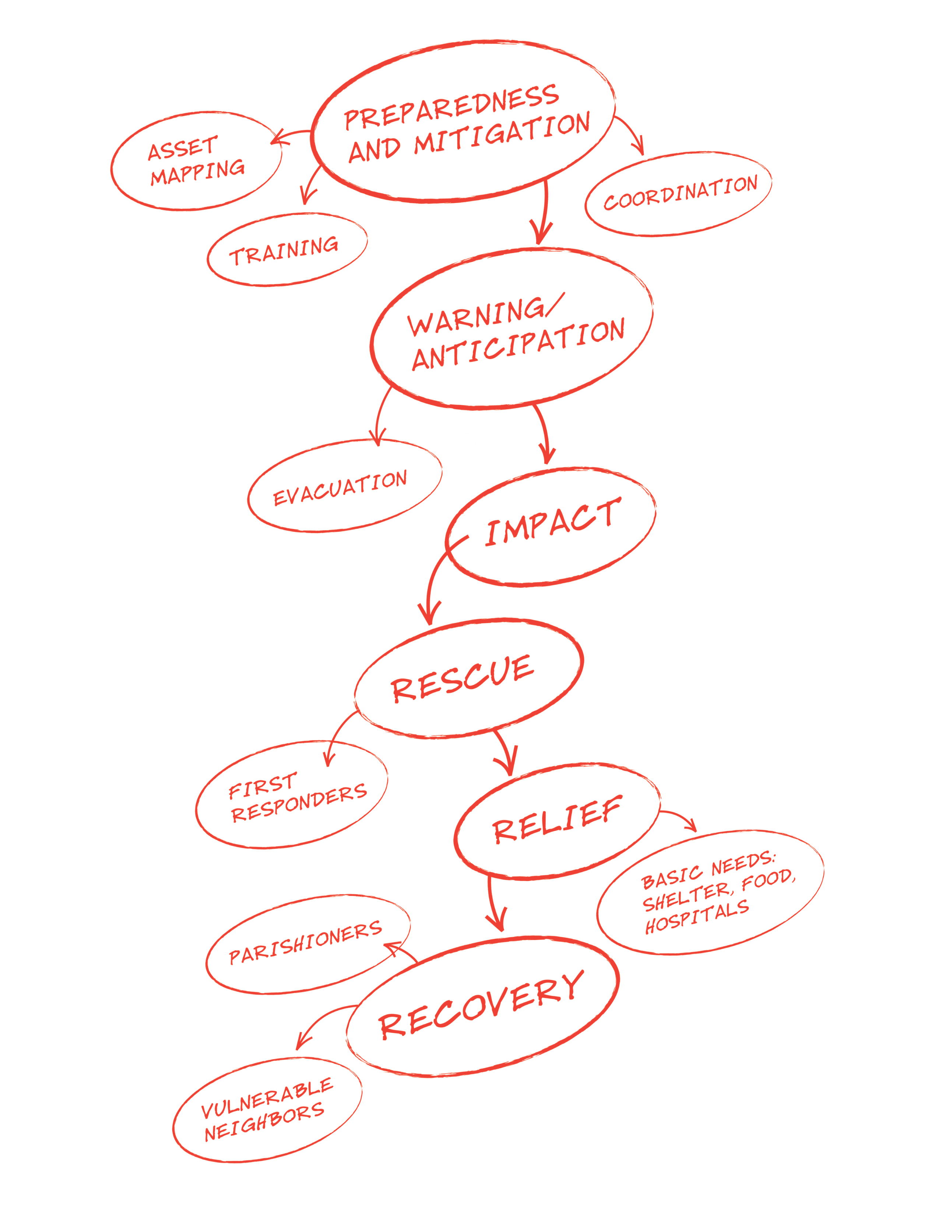
Developing Templates
For Initial Response

Now that you’ve determined your congregation’s capacity to respond to and recover from potential disasters and emergencies, you’re ready to apply this information to specific types of events. In most cases, the initial response to particular types of disasters will be very similar.

In this section, you will create templates for responding to four general types of crises:

- Major disasters with warning;
- Major disasters with no warning;
- Local emergencies with warning;
- Local emergencies with no warning.

To complete these templates, use the list generated on pg. 19, “Brainstorm Likely Disasters and Emergencies,” to help shape responses that reflect the disasters and emergencies particular to your region. A few examples are included to use as a general guide.

Your initial responses are really only the beginning of disaster response. They will get you through the first hours of a crisis until your Parish Disaster Leadership Committee can meet to determine further actions as the situation unfolds.

For more information on disasters and disaster planning please refer to Episcopal Relief & Development’s US Disaster Program website at www.episcopalrelief.org/usdisaster.
Example:
Initial Response for
Major Disasters with Warning

Description: This plan would work for anticipated disasters such as a major hurricane, where there is time to arrange for an evacuation and protect property before the disaster occurs.

First 10 steps:
 | Step | Time Frame | Person Responsible
1 | Call priest (xxx-xxx-xxxx) and sexton (xxx-xxx-xxxx) to protect property | Within 2 hours of evacuation notice | Congregational Disaster Coordinator
2 | Call Disaster Leadership Team to activate phone tree | Within 2 hours of evacuation notice | Congregational Disaster Coordinator
3 | Call Diocesan Disaster Coordinator to inform diocese of evacuation | Within 3 hours of evacuation notice | Congregational Disaster Coordinator
4 | Call St. Mark’s inland at xxx-xxx-xxxx to inform them of evacuation and when they can expect evacuees | Within 5 hours of evacuation notice | Congregational Disaster Coordinator
5 | Protect windows and doors, cover organ & unplug electronics | Within 5 hours of evacuation notice | Sexton and protection team
6 | Walk through church to make sure all valuables are stowed, protected or removed | Within 5 hours of evacuation notice | Sexton and protection team
7 | Take “Go Kit” | Within 8 hours of evacuation notice | Priest
8 | Activate evacuation plan for handicapped parishioners | Within 12 hours of evacuation notice | David Hamilton – owner of multiple vans
9 | Evacuate to partner parish | Within 12 hours of evacuation notice | Priest, staff & parishioners that need an evacuation destination
10 | Activate phone tree/communications plans to check on safety of parishioners | Within 24 hours after the storm has passed | Disaster Leadership Team

Prior Preparation:
Activity | Person Responsible
Hold “Preparedness Sunday” each May and collect evacuation plans/contact info for all staff and parishioners | Disaster Leadership Team
Prepare “Go Kit” for the church (pg. 30 – Preparedness Planning Guide) | Disaster Leadership Team & priest
Organize a team to help sexton protect property assets | Danielle Irons – sexton

Example:
Initial Response for
Local Emergencies with No Warning

Description: This plan would work for local emergencies such as a sudden snow storm

First 10 Steps:
 | Step | Time Frame | Person Responsible
1 | Congregational Disaster Coordinator calls priest to find out how the storm has affected the church and any activities/ministries | Within first hours | Congregational Disaster Coordinator
2 | Congregational Disaster Coordinator calls Disaster Leadership Team to tell them what is happening | Within first hours | Congregational Disaster Coordinator
3 | Activate notification system to inform students and parents that parish school has been cancelled | Within first hours | Director of parish school
4 | Disaster Leadership team activates Phone Tree to check up on at-risk parishioners and find out what they need | Within first 5 hours | Disaster Leadership Team
5 | If there is a need: use generator to run basic heat and light in parish hall | Within 24 hours | Danielle Irons – sexton
6 | Assess the needs of parishioners and the community |  | Congregational Disaster Coordinator  & Disaster Leadership Team
7 | Look at the assets your congregation can provide |  | Congregational Disaster Coordinator  & Disaster Leadership Team
8 | Meet to determine next steps |  | Congregational Disaster Coordinator  & Disaster Leadership Team
9
10

Prior Preparation:
Activity | Person Responsible
Have at least 5 gallons of gasoline onsite at the church, locked in the shed | Danielle Irons – sexton
Bi-annual check of the generator | Danielle Irons – sexton
Discuss volunteer responsibilities with Youth Group and others in case parish hall is put to use as heating shelter | Barbara Garcia – Team member
Cultivate relationship with important local community contacts | Diocesan Disaster Coordinator

Initial response for
Major Disasters with Warning

Examples of the such disasters most likely to affect our region:

First 10 steps: What are the first things that need to happen? By when do they need to start? And who is in charge?
 | Step | Time Frame | Person Responsible
1 | Call priest to find out how emergency has affected church and/or services/ministries |  | Congregational Disaster Coordinator
2 | Call Disaster Leadership Team to activate phone tree |  | Congregational Disaster Coordinator
3 | Call Diocesan Disaster Coordinator to inform diocese of what is happening |  | Congregational Disaster Coordinator
4
5
6
7
8
9
10

Prior Preparation: What needs to happen or what things are needed before a disaster in order to ensure the safety of the church and its parishioners?
Activity | Person Responsible
Initial response for
Major Disasters with No Warning

Examples of the such disasters most likely to affect our region:

First 10 steps: What are the first things that need to happen? By when do they need to start? And who is in charge?
 | Step | Time Frame | Person Responsible
1 | Call priest to find out how emergency has affected church and/or services/ministries |  | Congregational Disaster Coordinator
2 | Call Disaster Leadership Team to activate phone tree |  | Congregational Disaster Coordinator
3 | Call Diocesan Disaster Coordinator to inform diocese of what is happening |  | Congregational Disaster Coordinator
4
5
6
7
8
9
10

Prior Preparation: What needs to happen or what things are needed before a disaster in order to ensure the safety of the church and its parishioners?
Activity | Person Responsible

Initial Response for
Local Emergencies with Warning

Examples of the such emergencies most likely to affect our region:

First 10 steps: What are the first things that need to happen? By when do they need to start? And who is in charge?
 | Step | Time Frame | Person Responsible
1 | Call priest to find out how emergency has affected church and/or services/ministries |  | Congregational Disaster Coordinator
2 | Call Disaster Leadership Team to inform them what is happening |  | Congregational Disaster Coordinator
3 | Call Diocesan Disaster Coordinator to inform diocese of what is happening |  | Congregational Disaster Coordinator
4
5
6
7
8
9
10

Prior Preparation: What needs to happen or what things are needed before a disaster in order to ensure the safety of the church and its parishioners?
Activity | Person Responsible

Initial Response for
Local Emergencies with No Warning

Examples of the such emergencies most likely to affect our region:

First 10 steps: What are the first things that need to happen? By when do they need to start? And who is in charge?
 | Step | Time Frame | Person Responsible
1 | Call priest to find out how emergency has affected church and/or services/ministries |  | Congregational Disaster Coordinator
2 | Call Disaster Leadership Team to inform them what is happening |  | Congregational Disaster Coordinator
3 | Call Diocesan Disaster Coordinator to inform diocese of what is happening |  | Congregational Disaster Coordinator
4
5
6
7
8
9
10

Prior Preparation: What needs to happen or what things are needed before a disaster in order to ensure the safety of the church and its parishioners?
Activity | Person Responsible

Appendix: Table of Contents, All Versions
Table of Contents for Comprehensive, Silver and Bronze Planning Guides | Comp. | Silver | Bronze
Leadership  Who will take responsibility for preparedness activities? | 11
• Congregational Disaster Coordinator / Disaster Leadership Team | 12 | 7 | 7
• Disaster Leadership Team – Contact Information | 13
Goals  What does your congregation want to do in case of disaster? | 15
• Preparedness Goals / Forming Goals | 16 | 8
• Congregational Goals | 17 | 8
Risk Assessment  What emergencies have happened before and what should you prepare for? | 19
• Local Crisis History | 20
• Brainstorm Possible Disasters and Emergencies | 21 | 9
• Identify Groups that Include or Serve Vulnerable People | 22 | 10 | 8
Property Assets  What do you have that you need to protect? | 23
• Inventories of Property-Related Assets | 24 | 11
• Inventory Form | 25
• Items to Protect | 26
• Items to Bring in an Evacuation | 27
• Church "Go Kit" | 28
• Insurance Information | 29 | 12 | 9
• Secure Storage of Archives and Records | 30 | 13
Response & Recovery Capacity  What and whom do you have that will help you respond after an emergency? | 31
• Congregational Resources | 32 | 14
• Congregational Activities Resources | 33 | 15
• Members with Disaster-Related Skills/Certification/Resources | 35
• Member Questionnaire | 36
• Goals and Response | 39 | 17
Communication & Outreach  Whom do you need to contact after an emergency, how and for what purpose? | 41
• Important Contacts | 42
• Diocesan Contact Information | 43 | 18 | 10
• Church Staff Contact Information | 44 | 19
• People with Financial Authorization Approval | 44 | 19
• Congregation’s Emergency Contacts | 45 | 20
• Local Preparedness and Response Organizations | 46
• Vendor Contact List | 47
• Outside Users of the Building | 48 | 21
• Local Media Information | 49
Developing Templates for Initial Response  The first steps you should take in the immediate aftermath of a disaster | 51 | 22
• Example: Major Disasters with Warning | 52 | 23
• Example: Local Emergencies with No Warning | 53 | 24
• Template: Major Disasters with Warning | 54 | 25
• Template: Major Disasters with No Warning | 55 | 26
• Template: Local Emergencies with Warning | 56 | 27
• Template: Local Emergencies with No Warning | 57 | 28

The safe should have a rating of 4 to 5. If the safe is on a basement floor, it’s recommended that you keep it 6-8 inches above the floor on a concrete or durable slab.

