Diocesan Disaster Leadership Team

During a major disaster, it’s critical to establish the roles within a small leadership team, so that the team can operate efficiently and step in and out of roles as rest, illness and other circumstances require.

Here is one model, based on the Incident Command System, that we have found to be effective, keeping in mind that depending on the size of your office/staff/diocese, some of these roles might be filled by the same person. Also keep in mind that the goal is to identify people who will fill these roles, knowing that given illness and the need for rest will mean that people will cycle through roles. .

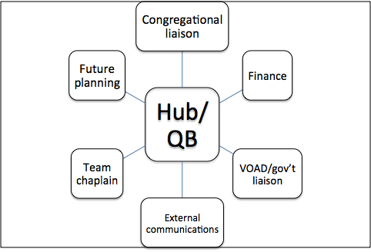

Role Descriptions

Hub/quarterback/team leader: This person convenes the meetings and is ultimately responsible for the team’s function and direction. Ideally this person liaises with Episcopal Relief & Development as needed, though that responsibility can be delegated if need be. | NAME  phone number(s)  email
Congregational liaison: This person is responsible for communicating with congregational leaders (and other church institutions if needed). If the area is too large, this person might have their own small team, or might use existing church structures such as deans to streamline communications. This person is determining needs and capacities within the churches. This person is likely managing the data regarding impacts on the churches as well as capacities. | NAME  phone number(s)  email
Finance: This person is responsible for tracking contributions and grants, distribution of funds, and general accounting around the disaster.This person may sit on the team intermittently as policies for expenditures need to be discussed | NAME  phone number(s)  email
NGO/gov’t liaison: This person attends the multitude of networking meetings/conference calls and/or finds others to attend and collects and distills the notes regarding how other non-profit, faith-based and government agencies are responding. This person might have a small team. . | NAME  phone number(s)  email
External communications: This person is responsible for communicating with the church at large and the broader community. This person often attends all team meetings, but is mindful about what can be shared and what is confidential, always checking if in doubt. | NAME  phone number(s)  email
Future planning and note taking: This person documents the work, distributing notes and is in charge of looking ahead. | NAME  phone number(s)  email
Team chaplain: This person chaplains this small team and is available to help with conflicts and challenges that emerge. Note, this person is not necessary the chaplain for the whole diocese or all clergy. | NAME  phone number(s)  email

Recommended protocol

Establish regular meeting times, at least once, if not twice per day. Ideally, the morning meeting is immediately after Episcopal Relief & Development regional call.

- Early morning and early evening often works well. Zoom or conference calls work great.
- Cap these meetings at 30 min.
- If the team leader is not a gifted meeting facilitator, appoint another person to lead the meetings!
- Open and close with prayer
- Send abbreviated notes from those meetings to the team daily. Be sure to flag what is confidential vs. what can be shared.
- Find times to name challenges and celebrate successes throughout the process.

