Domestic Mosquito Net Distributor

If you wish to purchase a mosquito net to use as a visual aid, follow these links to reputable mosquito net distributors:

http://www.rei.com/product/729007
Mombasa Outback Travel Mosquito Net via Recreational Equipment Incorporated

http://www.bedbathandbeyond.com/stylePage.asp?RN=197
Assorted netting via Bed, Bath, and Beyond

http://www.amazon.com/Coleman-827-350T-Mosquito-Net/dp/B00168V388
Low cost net via Amazon.com

http://www.nextag.com/nets-mosquito/compare-html?nxtg=97560a280509-65A173A15BD40A35
Purchase netting online to construct your own mosquito net

http://www.usnetting.com/HTML/mosquito-net.html
Purchase netting online to construct your own mosquito net

How to Construct a Mosquito Net

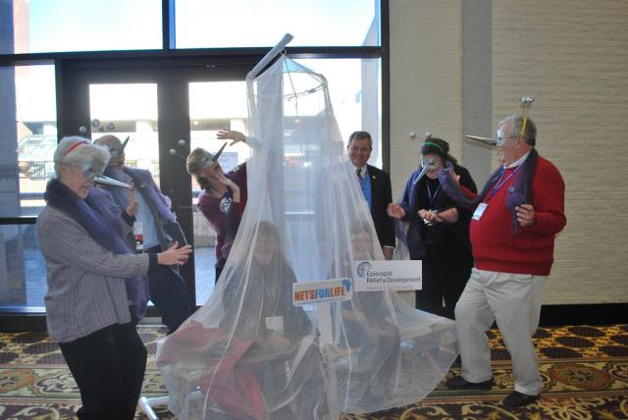
A display using a mosquito net will help create interest around your NetsforLife® campaign. Such displays don't necessarily need to take-up lots of space. Reasonably priced mosquito nets in various sizes can be found at the stores above, but those who are inclined to Do It Yourself craft projects, may be interested in these instructions.

Materials Needed:
Hula hoop
3 yards of tulle fabric (bridal veil material)
Hot glue gun with glue sticks
Fishing line

1. Hot glue the tulle fabric to the hula hoop core about 2 feet from one end of the fabric

2. Tie a knot in the short end of the fabric and attach fishing line there to hang the "net" (See image to the right)

Photo Courtesy of the Diocese of North Carolina for Episcopal Relief & Development

