NetsforLife®
Fall Activities Sheet

Fall is a great time to engage your children, youth, and parishes in the work of NetsforLife®. School is back in session and vacation has come to an end. So why not use this time to build unity in your community by rallying around a worthwhile endeavor? Here are some fun and creative ideas to help you join in the fight against malaria or use the tool kit resource items to enhance ideas of your own!

Keep it Simple
Try a fundraising event that requires little or no investment, like yard cleanups around the neighborhood. Those fall leaves are beautiful, but they sure do “fall” everywhere.

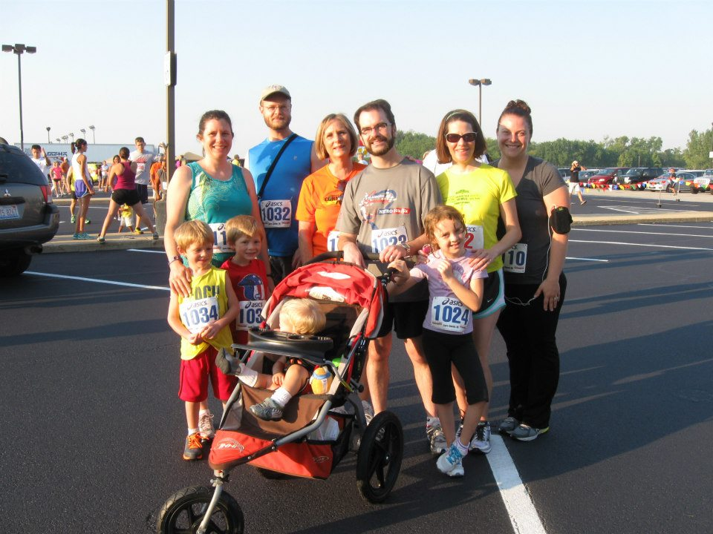
Fun Run
Take advantage of the beautiful fall weather by organizing a fun run or walk and charge an entrance fee. Offer entrants custom t-shirts or caps to make sure everyone who sees them knows which cause they’re walking for!

Gifts for Life Gift Cards
Gift cards are a great fundraising idea for any time of year.

Twelve-Day Fast
Decide on something you might purchase each day for $1. Give up that item for 12 days and "earn" $12 to buy a net.

Silent Auction
Seek donations of items related to nets. Examples include basketball game tickets, tennis lessons and a fishing vacation. Include a Slide Show presentation to celebrate the reason for giving, and your parishes’ partnership in the work of Episcopal Relief & Development and NetsforLife®!

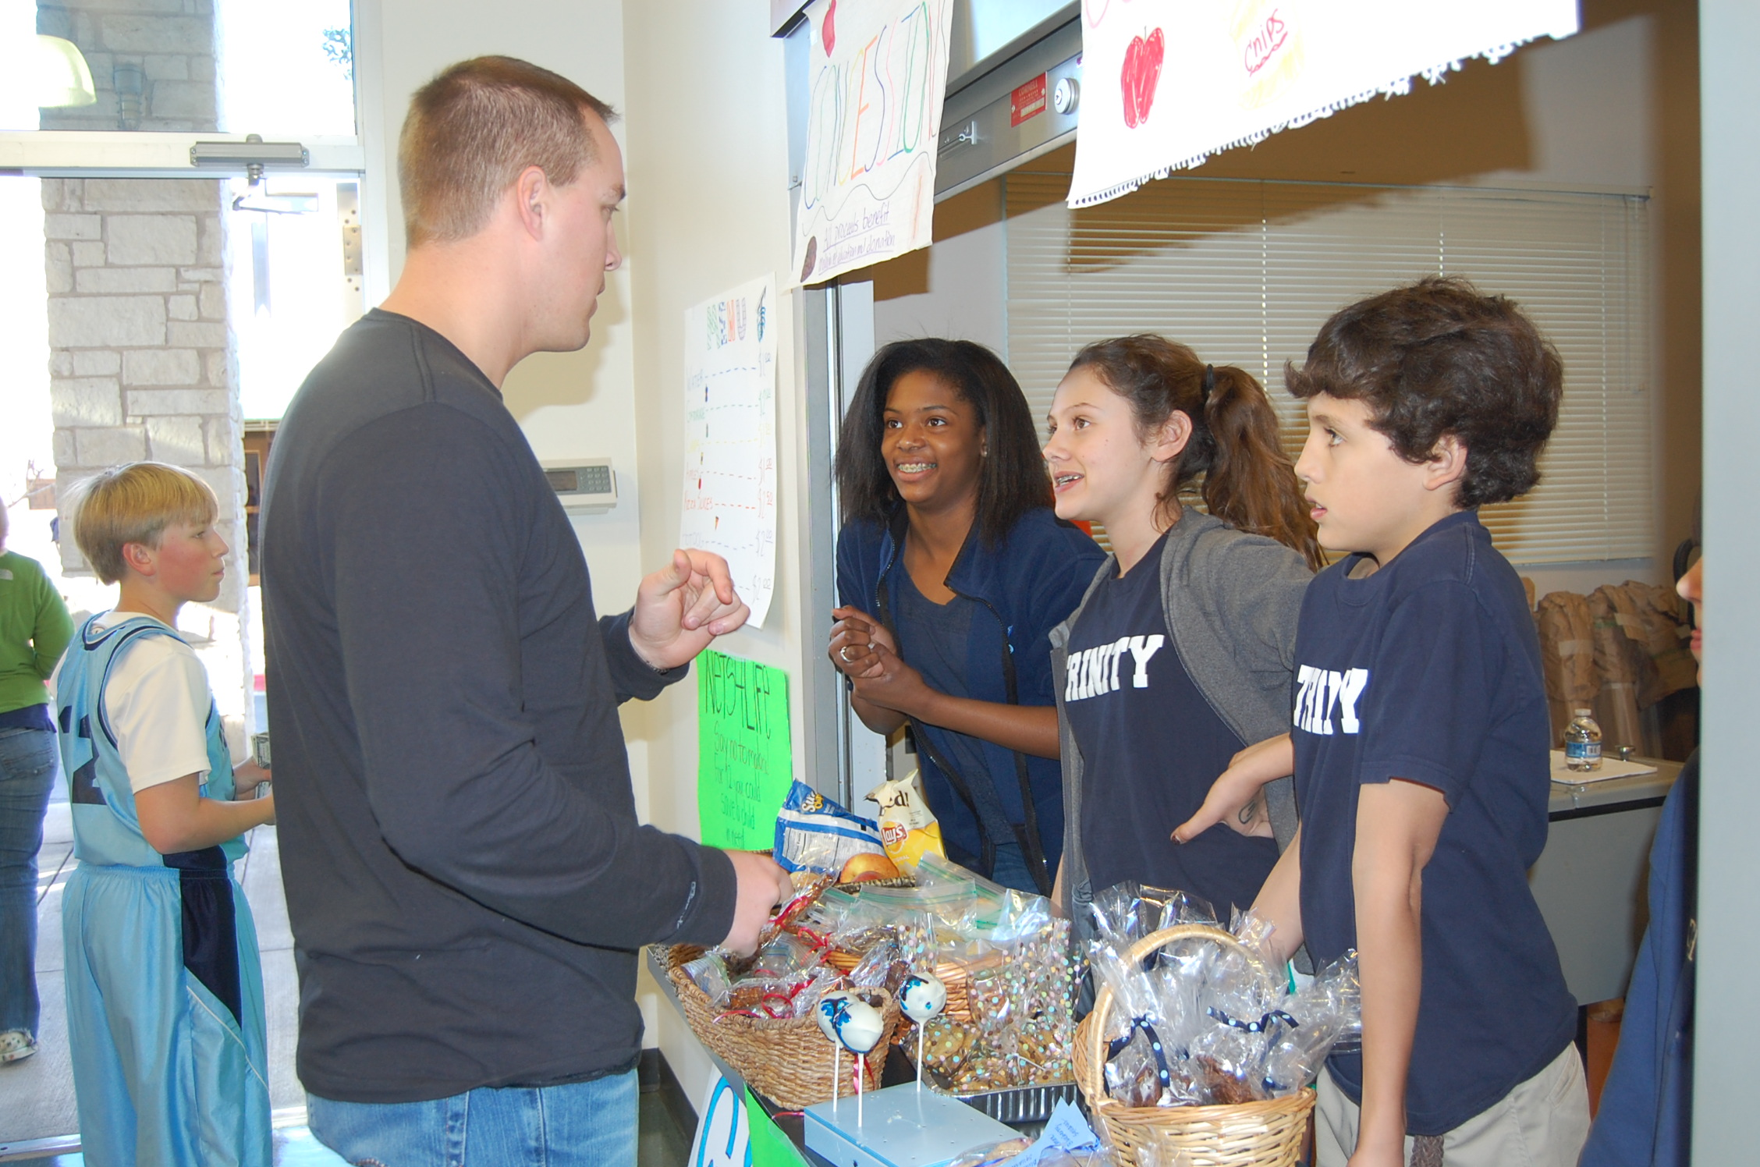
Sale, Sale, Sale
Polish your cooking skills for a bake sale during coffee hour. Hand out a Facts Sheet with each purchase to give your customers both knowledge and nourishment!

Popcorn and Movie Night
Invite friends and family to go to a popcorn and movie night and ask for a minimum donation to attend, such as $12. You can show a family-friendly or any other popular movie.

Matching Gifts
Many companies match the fundraising of their employees, be sure to check!

Potluck Benefit Dinner
Have each runner bring a big dish to share and at least one friend (hopefully more)! Ask for a minimum donation from each guest. If you want to get extra fancy, you could invite a special speaker or include a small raffle.

Social Media
Facebook and Twitter can create powerful social change – post a request to your friends/family asking for pledges. Repeat the post about once a week as a reminder – not everyone will take action the first time he or she sees it (and some will not take action at all.)

Organizational Engagement
Involve your fraternity or sorority, choir, sports team, band, or other group in which you are involved. Chat with them about how they might help support your fundraising efforts.
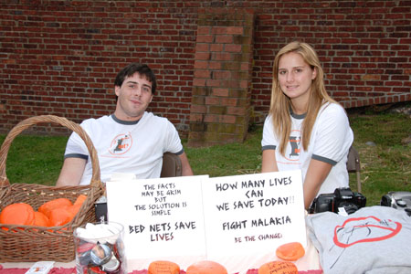
Alternative Gifts
Instead of birthday or holiday gifts, ask your friends and family to make a donation. The tax deduction they will receive may enable them to contribute a larger gift.

Just-for-Fun Game
Sports like football, basketball and Hockey are lots of fun in the fall and winter, and also a great way to raise funds. Organize fun games like parents vs. kids, girls vs. boys, etc, and charge a small fee to join a team, or allow people to join in with a donation amount of their choice.

All Saints Day Cleanup
Little ghosts and goblins can wreak havoc on yards and pumpkins during Halloween. Have an all saints day cleanup for your next fundraiser. Create a flyer about your group and what you are raising money for. Advertise locally with signs and in your local newspaper that you will be going around the day after Halloween cleaning up yards for a donation.

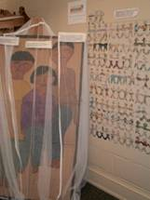
Coffee House and Open Mike Night
Lattes, mochas, and cappuccinos… Coffee houses are sweeping the nation and are the place to hang out on Friday or Saturday night. This fundraiser works great for a school or church group and is appropriate for all ages. Have a microphone and invite people to share a favorite poem they have written or one written by their favorite poet. This will be a fun time for all.

Fall Color Tour
Reds, oranges, and yellows… Its nature’s art show and it’s free for everyone to enjoy. This is a great fundraiser for areas that leaves on trees change colors in the fall. People love to make a day of driving around and enjoying the fall colors, but someone has to drive and they are not able to pay as much attention as they would like. Take over the responsibility driving and host a fall color tour.

Harvest Fest
This fundraiser can be as simple or elaborate as you like. Take advantage of the fall harvest and Halloween season to have a Harvest Fest. Have a bake sale with items made with apples and pumpkins, such as pies, cookies, and muffins. Or, have an old fashioned gourd tossing competition with a makeshift catapult…this is a great way to get rid of those used up jack-o-lanterns.

Pancake Breakfast
This is one of the most common fundraisers because it's easy and inexpensive to plan, and who doesn't like pancakes? This kind of fundraiser is great for Sundays, and makes a great church fundraiser. If you can hold it at your church, everyone can come by and have a warm breakfast after services.

Decorate the Sanctuary
Hang Mosquito bed nets in the sanctuary: from the ceiling, on the walls, outside on the building or the church sign, or create a display using a mosquito net to promote NetsforLife®. This kind of engaging display is hard to ignore, and is sure to highlight the realities of “Net Culture” to parishioners of all ages!

Remember to use the tool kit resource items to enhance ideas of your own!

