Story from the Field
Parko Clinic

Ghana - For four years, Ruth Owusu has been the Head Midwife at Parko Health Clinic. There are no doctors or nurses assigned to the clinic. Therefore, Ruth oversees the daily operations of the clinic with the help of two assistants.
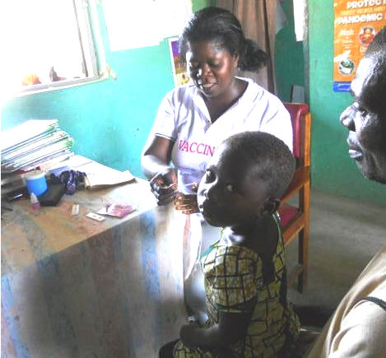
Ruth is pleased the mass bed-net distribution throughout the country. She commented that half of the cases that come into her clinic are malaria related. She tells NetsforLife® that malaria is endemic in her area and that she uses Rapid Diagnostic Tests (RDTs) to diagnose malaria and usually prescribes Artemisinin to treat the illness.

Ruth advises every patient that visits the clinic to sleep under a Long-Lasting Insecticide Treated Mosquito Net (LLIN) even if they test negative for malaria. However, due to the high poverty levels in her area, it is difficult for patients to purchase an LLIN.

She explains that the Ministry of Health has made RDTs mandatory in Ghana helping to ease the burden of having to send her patients far distances for testing and diagnoses. However, Ruth mentions that there has been a shortage of Intermittent Preventive Treatment of malaria during pregnancy (IPTp) for the past 6 months resulting in a rise in malaria cases in pregnant women.
Photo courtesy of Episcopal Relief & Development
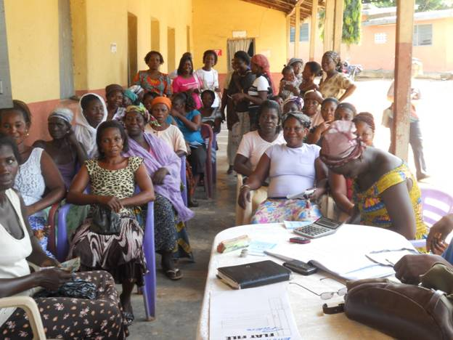
While speaking with NetsforLife®, she administered a RDT to a small child with sickle cell, whose grandfather brought her in because she had a fever. The little girl was confirmed to have malaria. Luckily, she will receive treatment and a LLIN will be hung in her home to prevent future infection.

Malaria is the cause of 22% of child deaths in Ghana every year, and is a chief factor in low productivity and subsequent poverty, especially in the northern region.

With your help, NetsforLife® is working to building stronger, healthier communities in Ghana.
Photo courtesy of Episcopal Relief & Development

NetsforLife® is a partnership of corporations, foundations, nongovernmental groups, and faith based organizations working to fight malaria. The program partnership includes ExxonMobil, Standard Chartered Bank, the Coca-Cola Africa Foundation, Starr International Foundation, the J.C. Flowers Foundation, and Episcopal Relief & Development.

