Story from the Field
Uganda

UGANDA - Though Uganda has experienced a period of political stability and economic growth since the 1990s, an estimated 35% of Ugandans still live in poverty. The majority of Ugandans (about 88%) live in rural areas, where subsistence agriculture is the major source of food and income.
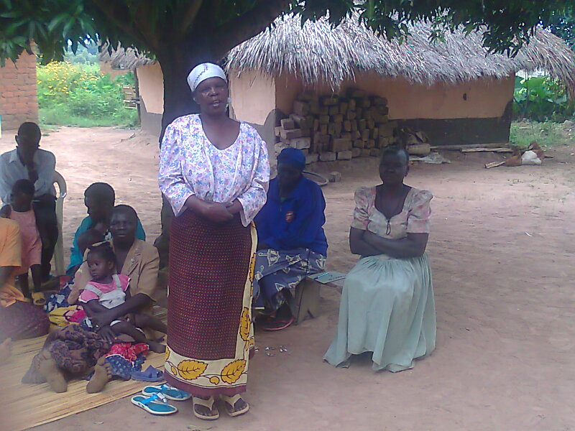
Today, malaria is a leading cause of illness and death in Uganda. It is responsible for 40% of all outpatient visits, 25% of hospital stays and 14% of deaths in the hospital. Children under age five and pregnant women constitute the majority of malaria cases.

Christian Aid is the NetsforLife® partner in Uganda, working directly with churches on the ground to fight malaria, and through this partnership, NetsforLife® has reached over two million beneficiaries both directly and through education on net use, training on malaria, and ongoing monitoring and evaluation.
Zainab talking to her fellow villagers about how she has benefited from Netsforlife®

Zainab Anguzu is a NetsforLife® beneficiary living in the Arua District of the Madi West Nile Diocese in Northern Uganda. Zainab is the second wife of Hajji Badru Anguzu who has ten children, four of which are Zainab’s children, and the rest are the children of another wife. As Muslim wives, they are obliged to cooperate with one another. The wives take the children to the hospital or to a health center when they fall ill. This can be very difficult since the nearest health center is far away and their only means of transportation is a bicycle.

Due to NetsforLife®, Zainab and her co-wife celebrate the fact that they do not have to seek medical treatment for their children at the health center any longer. Zainab recently bought a shamba, plot of land for gardening, with the money she has saved from not having to take the children to the doctor. She is joyful at knowing how to detect malaria in her children because of the training she received from the NetsforLife® Malaria Control Agents and able to teach her neighbors about how to prevent malaria.

Since 2006, NetsforLife® has distributed over 11 million nets as part of its campaign to fight malaria resulting in less sickness, fewer deaths and stronger communities. Combined with the community education and net monitoring work of nearly 81,000 trained Malaria Control Agents, these nets have saved the lives of over 100,000 children under five and reduced the number of malaria cases by up to 45% in communities where NetsforLife® is active.

