Frequently Asked Questions About
Malaria, NetsforLife® and Long-lasting, Insecticide-treated Nets (LLINs)
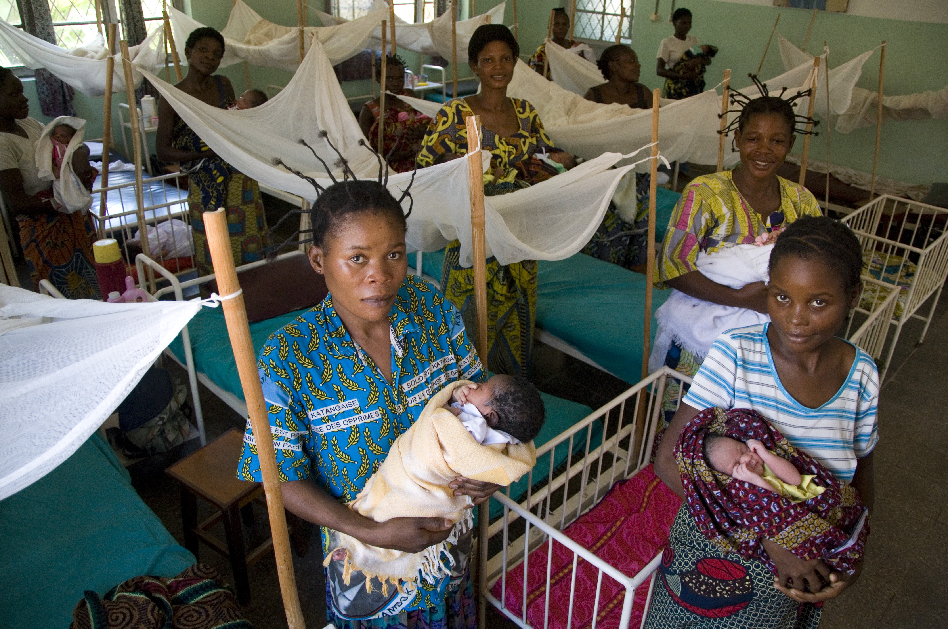
What is malaria?
Malaria is a common but deadly disease caused by parasites. Humans contract malaria when a mosquito carrying the parasite bites them, and injects the parasite into the bloodstream.

What are the symptoms of malaria?
Malaria symptoms typically appear 10 to 16 days after the infectious mosquito bite, when the infected red blood cells begin to burst. Those affected experience flu-like symptoms, including chills, fever, sweating, nausea, headaches and vomiting.
Photo courtesy of John Robinson for Episcopal Relief & Development

What kind of parasite carries malaria?
There are four species of parasites that cause malaria in humans. The most common species in Africa is known as Plasmodium falciparum. This species causes the most virulent form of the disease, which can be fatal within hours if not treated.

Who is most vulnerable to malaria?
Nearly one million people die from malaria each year, mostly children younger than five years old. Young children are most vulnerable because they have not built up any immunity to the disease, and without immunity, the infections tend to be more severe and life-threatening.

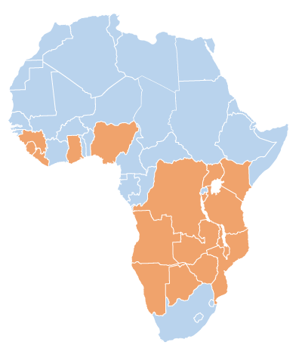Pregnant women are at risk because their immune systems are compromised by pregnancy. Additionally, infants born to women who had malaria during their pregnancies tend to be of low birth weight or premature, both of which decrease their chances of survival during their first years.
Where is NetsforLife® working?
NetsforLife® serves 17 countries in sub-Saharan Africa. The success of the program is a result of the NetsforLife® partnerships with a network of faith-based organizations working on the ground in Africa. As active and trusted members of local communities, the program has distributed over 11 million nets and trained over 82,000 malaria control agents.

What is unique about NetsforLife®?
The program’s methodology is to collaborate with existing national malaria programs to mobilize, train and educate volunteers in working together to eliminate the disease by instilling a 'net culture'—defined as the community-wide understanding of the protective value of nets and the right way to use and maintain them.

In addition to the distribution of nets, a main component of the initiative is education about malaria transmission and prevention. Communities learn about the importance of using mosquito nets and receive detailed knowledge about proper net use and maintenance. When the program began in 2006, only four out of ten people understood how malaria was transmitted in the communities NetsforLife® was present. Now, nine out of every ten people understand how the disease spreads.

How does NetsforLife® empower communities to help themselves?
Without the buy-in of communities from training, implementation, and follow-up, NetsforLife® could not have celebrated its many successes. Community engagement is usually done at least 3 months prior to any net distribution. In many cases, local traditional, religious and political leaders are brought into the process early on and are continually consulted as resources. Malaria control agents are people selected by the communities to be trained and in-turn educate their own communities on malaria, distribute nets and assist with program monitoring and evaluation. They live in the communities where they work and are a sustainable resource.

How does NetsforLife® monitor and evaluate its work?
A baseline study is conducted in each community to assess the number of malaria cases, use of nets, the populations most at risk and the barriers to treatment (such as lack of proximity to clinics, inadequate health-care facilities, cost of treatment, no access to drugs). Formal monitoring begins at three months (or after the next rainy season, whichever comes first) and continues for 18 months after each net is hung.
Evaluation of program impact in communities includes reviewing data on malaria incidences from health-care facilities, developing community surveillance methods; and involving the community in the assessment process. Monitoring and evaluation is a critical piece in the fight against malaria. The NetsforLife® monitoring and evaluation has been initiated in all countries and is independently verified.

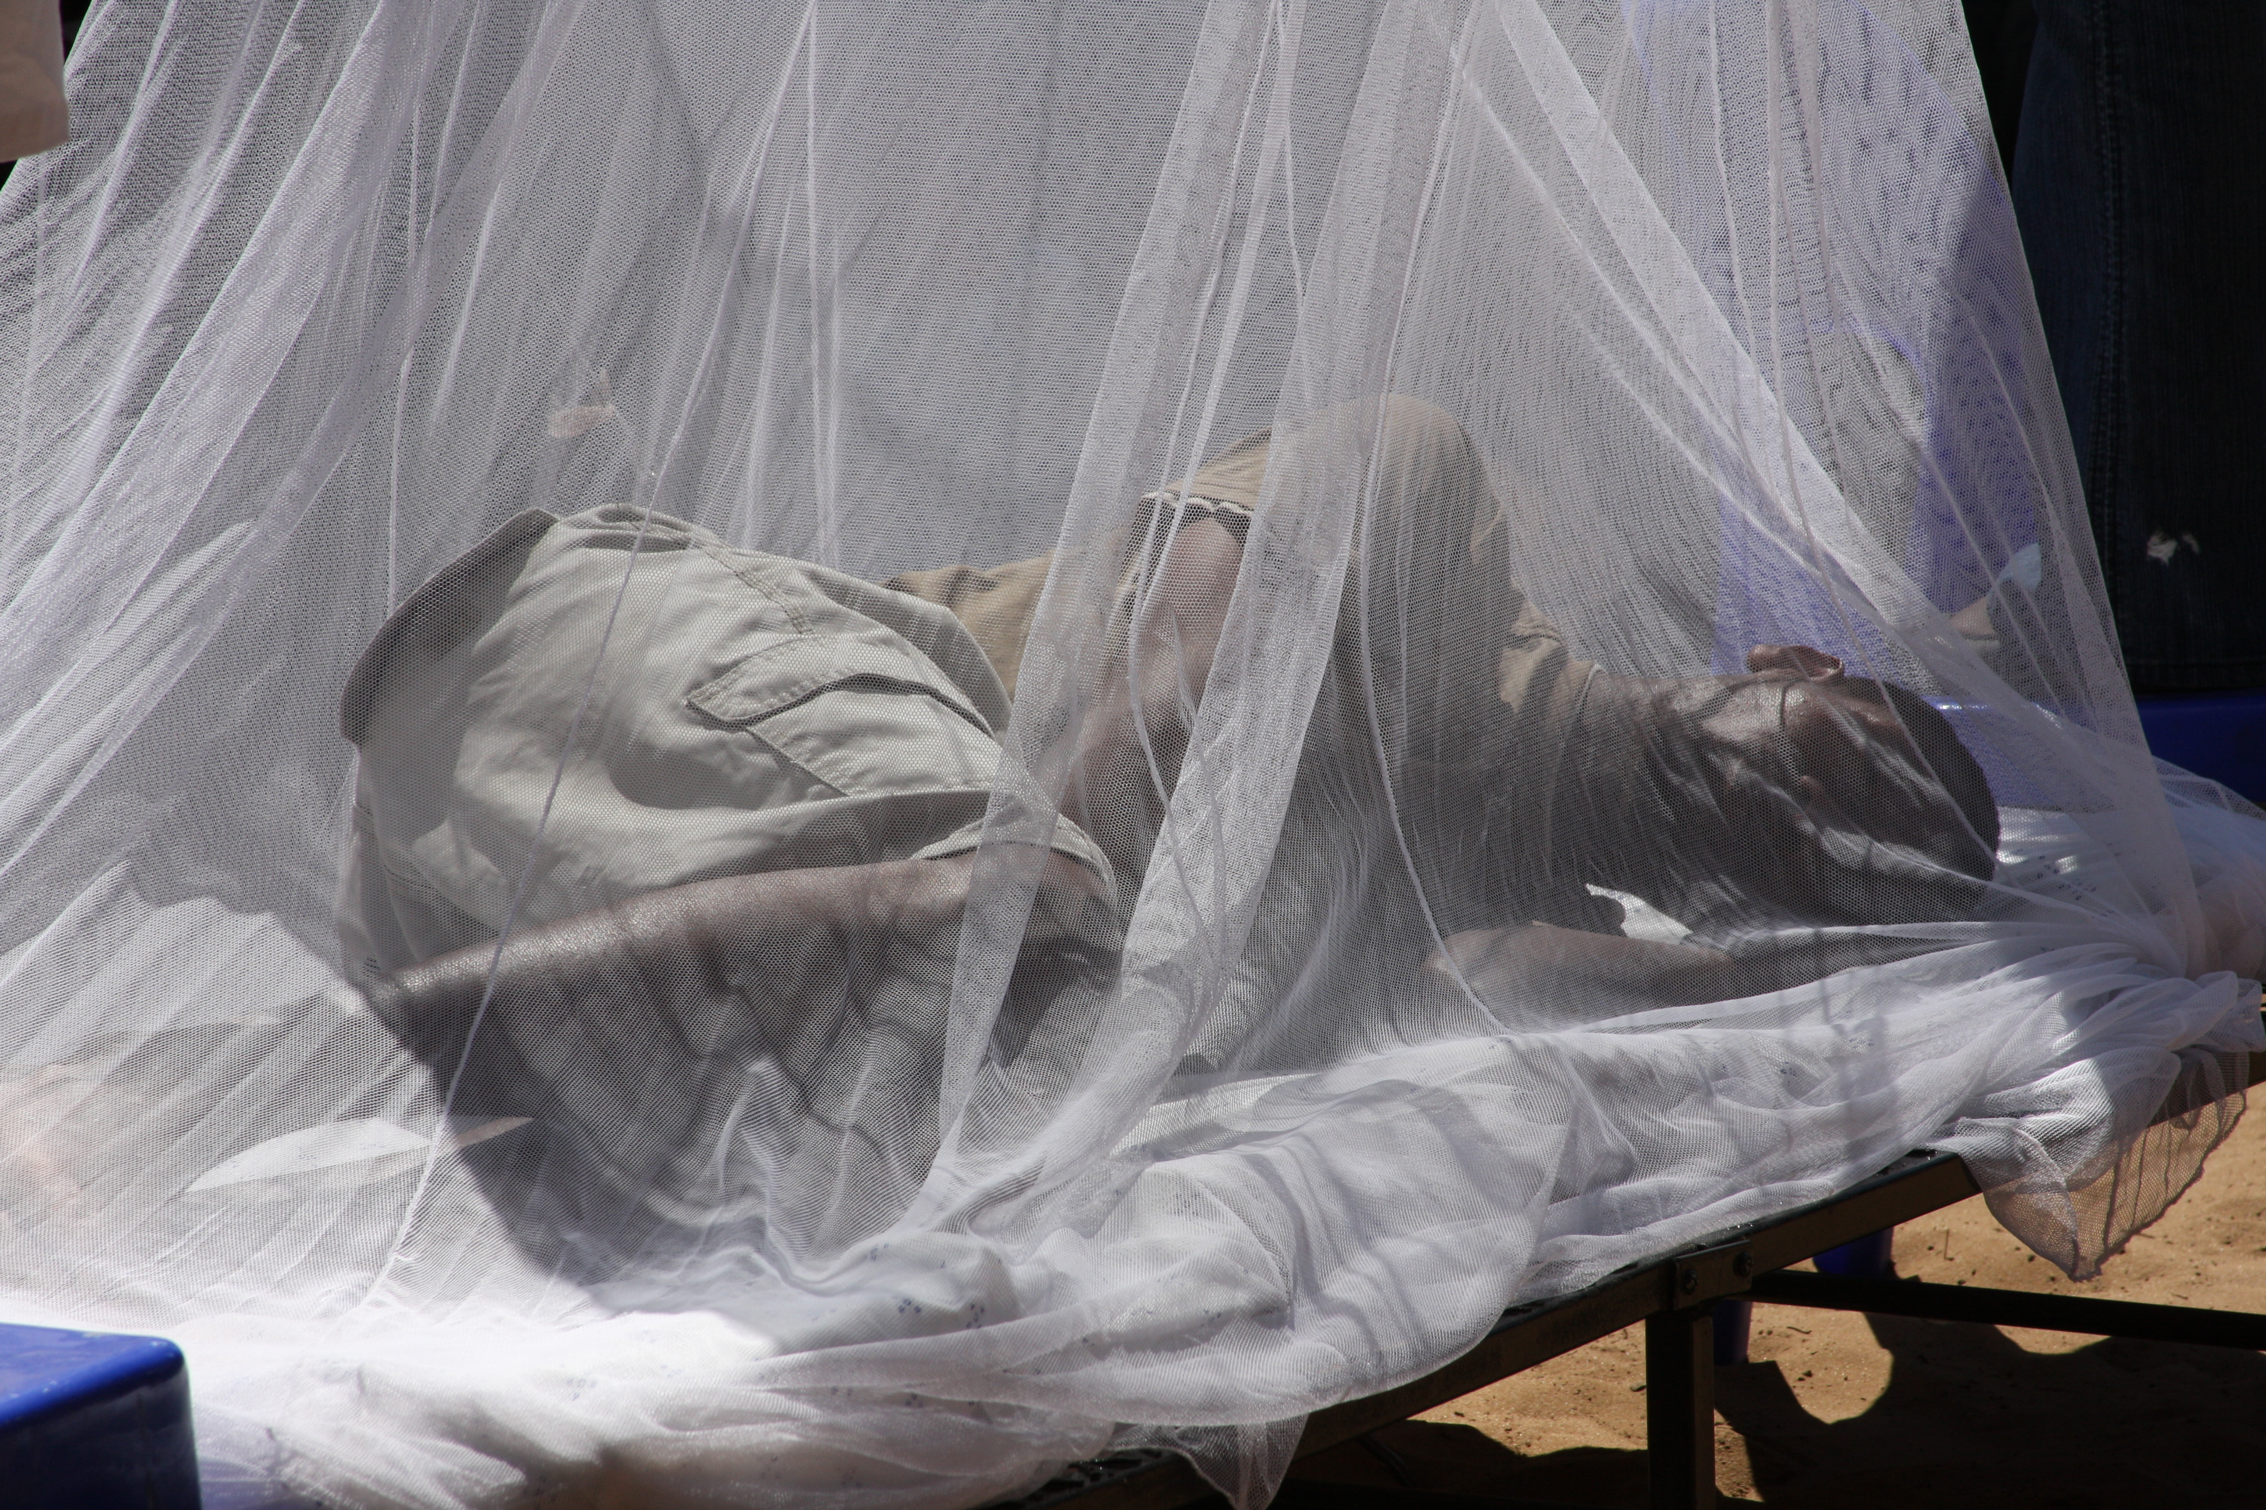Why are the nets effective in preventing malaria?
Since most malaria-carrying mosquitoes bite at night, the simplest and most effective preventive technique is sleeping under an insecticide-treated bed net. Sleeping under an insecticide-treated net protects against malaria by repelling and killing malaria-carrying mosquitoes.

NetsforLife® only distributes long-lasting insecticide-treated nets approved by the World Health Organization (WHO) along with the appropriate training and use of the nets. Long-lasting insecticide-treated nets (LLIN) are infused with an insecticide that remains effective for up to 20 washes or up to three years. The insecticide will kill those mosquitoes that have been exposed to it, as well as reduce the number of mosquitoes that enter the house.
Photo courtesy of Laura Ellen Muglia for Episcopal Relief & Development.

Research shows that when three-quarters of the people in a community use nets properly, malaria transmission is cut by 50%, child deaths are cut by 20%, and the mosquito population drops by as much as 90%.

How long do nets last?
All of the manufacturers used by NetsforLife® rate their nets for 5 years. In actuality, the number is closer 3 years. This of course depends on a number of factors including temperature, the intensity of the rainy season, the number of hand-washings in local water sources, the environment, and normal wear and tear all contribute to decreasing the effectiveness of the LLIN’s.

What does NetsforLife® do to replace nets when they wear out?
NetsforLife® works with local partners to replace nets in communities to ensure the gains made in malaria prevention are maintained. Net replacement is a critical piece to malaria control globally.

For every ten nets distributed by NetsforLife®, at least one community member will acquire a net on their own because they have heard “the message” in their community. Between 2006 and 2009, nearly 200,000 community members who did not receive nets through NetsforLife® took the initiative to acquire their own net.

